**COVID-19 ANALYSIS**

by

TANMAY KUMAR SINHA 18BEC1115

ANKUSH BADGUJAR 18BEC1054

JIGYAS ARORA 18BEC1067

A project report submitted to

**Dr. VETRIVELAN. P**

**SCHOOL OF ELECTRONICS ENGINEERING**

in partial fulfilment of the requirements for the course of

**CSE3505 – FOUNDATIONS OF DATA ANALYTICS**

in

**B.Tech. ELECTRONICS AND COMMUNICATION ENGINEERING**



**Vandalur – Kelambakkam Road**

**Chennai – 600127**

**NOVEMBER 2020**

**BONAFIDE CERTIFICATE**

Certified that this project report entitled “**COVID-19 ANALYSIS”** is a bonafide work of **TANMAY KUMAR SINHA – 18BEC1115, ANKUSH BADGUJAR – 18BEC1054 and JIGYAS ARORA – 18BEC1067** who carried out the Project work under my supervision and guidance for **CSE3505-Foundations of Data Analytics.**

**Dr. VETRIVELAN.P**

Associate Professor Senior & HoD-B.Tech(ECE)

School of Electronics Engineering (SENSE),

VIT University, Chennai

Chennai – 600 127.

**ABSTRACT**

On 31 December 2019, the first reported case in the COVID-19 outbreak was reported in Wuhan, China. The first case outside of China was reported in Thailand on 13 January 2020 . Since then, this ongoing outbreak has now spread to more than 50 other countries . WHO declares COVID-19 outbreak as a Public Health Emergency of International Concern (PHEIC) by WHO on 30 January 2020 . There are over 76,000 cases of confirmed COVID-19 worldwide as of 20 February. An infectious disease outbreak is the occurrence of a disease that is not usually expected in a particular community, geographical region, or time period . Typically, a rising infectious disease involves fast spreading, endangering the health of large numbers of people, and thus requires immediate action to prevent the disease at the community level. COVID-19 is caused by a new type of coronavirus which was previously named 2019-nCoV by the World Health Organization (WHO). It is the seventh member of the coronavirus family, together with MERSnCoV and SARS-nCoV, that can spread to humans. The symptoms of the infection include fever, cough, shortness of breath, and diarrhea. In more severe cases, COVID-19 can cause pneumonia and even death. The incubation period of COVID-19 can last for 2 weeks or longer. During the period of latent infection, the disease may still be infectious. The virus can spread from person to person through respiratory droplets and close contact. So we have done an analysis on how each country is being affected during these tough times and how have they reacted and taken what measures to reduce the spread of this infectious disease in their country.

**ACKNOWLEDGEMENT**

We wish to express our sincere thanks and deep sense of gratitude to our project guide, **Dr. Vetrivelan. P,** Associate Professor Senior, School of Electronics Engineering, for his consistent encouragement and valuable guidance offered to us in a pleasant manner throughout the course of the project work.

We are extremely grateful to **Dr. Sivasubramanian. A,** Dean of School of Electronics Engineering, VIT Chennai, for extending the facilities of the School towards our project and for her unstinting support.

We express our thanks to our Head of the Department **Dr. Vetrivelan. P** for his support throughout the course of this project.

We also take this opportunity to thank all the faculty of the School for their support and their wisdom imparted to us throughout the course.

We thank our parents, family, and friends for bearing with us throughout the course of our project and for the opportunity they provided us in undergoing this course in such a prestigious institution.

**TANMAY ANKUSH JIGYAS**

**TABLE OF CONTENTS**

|  |  |  |  |
| --- | --- | --- | --- |
| **SL. NO.** |  | **TITLE** | **PAGE NO.** |
|  |  | ABSTRACT | 3 |
|  |  | ACKNOWLEDGEMENT | 4 |
|  |  |  |  |
| 1 |  | INTRODUCTION | 6 |
|  |  |  |  |
|  | 1.1 | OBJECTIVES | 6 |
|  | 1.2 | BENEFITS | 6 |
|  | 1.3 | FEATURES | 6 |
|  |  |  |  |
| 2 |  | COVID-19 ANALYSIS SOFTWARE- DESIGN | 7 |
|  |  |  |  |
|  | 2.1 | SOFTWARE SPECIFICATIONS | 17 |
|  |  |  |  |
| 3 | 3.1  3.2 | COVID 19 ANALYSIS - IMPLEMENTATION AND ANALYSIS  CODE IMPLEMENTATION  RESULTS AND INFERENCES | 8-48  8-33  34-48 |
|  |  |  |  |
| 4 |  | CONCLUSION AND FUTURE WORK | 49 |
|  | 4.1 | CONCLUSION | 49 |
|  | 4.2 | FUTURE WORK | 49 |

5 REFERENCES 50

BIO-DATA 51

**CHAPTER 1**

**INTRODUCTION**

**1.1 OBJECTIVES**

* To analyse the outbreak of the novel Coronavirus in Various countries.
* Comparing the confirmed cases in each country.
* Comparing the recovered cases in each country .
* Comparing the death rates in each country.
* Effect of measures taken by the government authorities to tackle the novel coronavirus.

**1.2 BENEFITS**

COVID-19 is a very fatal disease and hence by the help of the analysis we can easily see which areas are most affected by this fatal disease and which area can take more preventive measures and which areas in the world can take some privileges for freedom.

**1.3 FEATURES**

* Comparison between the modern countries.
* Knowing the areas where COVID-19 has the maximum and minimum spread.
* Getting to know the areas where more preventive measures should be taken.
* Identifying areas that are safe from this Novel Coronavirus.

**CHAPTER 2**

**COVID-19 Analysis - DESIGN**

**2.1 SOFTWARE SPECIFICATIONS**

* **R programming**
* **HTML Output Implementation using R MarkDown Language**

**CHAPTER 3**

**SYSTEM IMPLEMENTATION AND ANALYSIS**

This section describes the code implementation in .Rmd with R code chunks and results with inferences.

**3.1 CODE IMPLEMENTATION**

---

title: "COVID-19"

author: "Ankush Jigyas Tanmay"

date: "10/09/2020"

output:

html_document:

toc: yes

fig_caption: yes

---

```{r setup, include=FALSE}

knitr::opts_chunk$set(echo = TRUE)

```

#### Dataset source for this project is https://github.com/CSSEGISandData/COVID-19/tree/master/csse_covid_19_data/csse_covid_19_time_series

## LOADING LIBRARIES

```{r}

library(magrittr) # pipe operations

library(lubridate) # date operations

library(tidyverse) # ggplot2, tidyr, dplyr...

library(gridExtra) # multiple grid-based plots on a page

library(ggforce) # accelerating ggplot2

library(kableExtra) # complex tables

library(leaflet) # map

```

#LOADING DATA

```{r}

## load data into R

raw.data.confirmed <- read.csv('time_series_covid19_confirmed_global.csv')

raw.data.deaths <- read.csv('time_series_covid19_deaths_global.csv')

raw.data.recovered <- read.csv('time_series_covid19_recovered_global.csv')

dim(raw.data.confirmed)

```

# Data Preparation

## Extracting first 10 data

```{r}

# getting First 10 data

dt<-raw.data.confirmed[1:10, 1:10]

kable(dt, booktabs=T, caption='Raw Data (Confirmed, First 10 Columns only)')%>%

kable_styling(latex_options = c('striped', 'hold_position', 'repeat_header'),full_width = F)

```

## Getting Information about dates from the data

```{r}

n.col <- ncol(raw.data.confirmed)

## get dates from column names

dates <- names(raw.data.confirmed)[5:n.col] %>% substr(2,8) %>% mdy()

range(dates)

```

## Formatting the dates

```{r}

min.date <- min(dates)

max.date <- max(dates)

min.date.txt <- min.date %>% format('%d %b %Y')

max.date.txt <- max.date %>% format('%d %b %Y') %>% paste('UTC')

print(max.date.txt)

```

## DATA CLEANING

```{r}

## data cleaning and transformation

cleanData <- function(data) {

## remove some columns

data %<>% select(-c(Province.State, Lat, Long)) %>% rename(country=Country.Region)

## convert from wide to long format

data %<>% gather(key=date, value=count, -country)

## convert from character to date

data %<>% mutate(date = date %>% substr(2,8) %>% mdy())

## aggregate by country

data %<>% group_by(country, date) %>% summarise(count=sum(count, na.rm=T)) %>% as.data.frame()

return(data)

}

## clean the three datasets

data.confirmed <- raw.data.confirmed %>% cleanData() %>% rename(confirmed=count)

data.deaths <- raw.data.deaths %>% cleanData() %>% rename(deaths=count)

data.recovered <- raw.data.recovered %>% cleanData() %>% rename(recovered=count)

## merge above 3 datasets into one, by country and date

data <- data.confirmed %>% merge(data.deaths, all=T) %>% merge(data.recovered, all=T)

# data %<>% mutate(recovered = ifelse(is.na(recovered), lag(recovered, 1), recovered))

## countries/regions with confirmed cases, excl. cruise ships

countries <- data %>% pull(country) %>% setdiff('Cruise Ship')

```

## Getting first 10 cases record from China

```{r,results='asis', echo=FALSE}

## first 10 records when it first broke out in China

library(knitr)

data %>% filter(country=='China') %>% head(10) %>%

knitr::kable(booktabs=T, caption='Raw Data (with first 10 Columns Only)',

format.args=list(big.mark=',')) %>%

kableExtra::kable_styling(latex_options = c('striped', 'hold_position', 'repeat_header'))

```

## Worldwide cases

```{r}

## counts for the whole world

data.world <- data %>% group_by(date) %>%

summarise(country='World',

confirmed = sum(confirmed, na.rm=T),

deaths = sum(deaths, na.rm=T),

recovered = sum(recovered, na.rm=T))

data %<>% rbind(data.world)

## current confirmed cases

data %<>% mutate(current.confirmed = confirmed - deaths - recovered)

```

## Daily Increases and death rates

```{r}

## sort by country and date

data %<>% arrange(country, date)

## daily increases of deaths and recovered cases

## set NA to the increases on day1

n <- nrow(data)

day1 <- min(data$date)

data %<>% mutate(new.confirmed = ifelse(date == day1, NA, confirmed - lag(confirmed, n=1)),

new.deaths = ifelse(date == day1, NA, deaths - lag(deaths, n=1)),

new.recovered = ifelse(date == day1, NA, recovered - lag(recovered, n=1)))

## change negative number of new cases to zero

data %<>% mutate(new.confirmed = ifelse(new.confirmed < 0, 0, new.confirmed),

new.deaths = ifelse(new.deaths < 0, 0, new.deaths),

new.recovered = ifelse(new.recovered < 0, 0, new.recovered))

## death rate based on total deaths and recovered cases

data %<>% mutate(rate.upper = (100 * deaths / (deaths + recovered)) %>% round(1))

## lower bound: death rate based on total confirmed cases

data %<>% mutate(rate.lower = (100 * deaths / confirmed) %>% round(1))

## death rate based on the number of death/recovered on every single day

data %<>% mutate(rate.daily = (100 * new.deaths / (new.deaths + new.recovered)) %>% round(1))

## convert from wide to long format, for drawing area plots

data.long <- data %>%

select(c(country, date, confirmed, current.confirmed, recovered, deaths)) %>%

gather(key=type, value=count, -c(country, date))

## set factor levels to show them in a desirable order

data.long %<>% mutate(type=recode_factor(type, confirmed='Total Confirmed',

current.confirmed='Current Confirmed',

recovered='Recovered',

deaths='Deaths'))

## convert from wide to long format, for drawing area plots

rates.long <- data %>%

# filter(country %in% top.countries) %>%

select(c(country, date, rate.upper, rate.lower, rate.daily)) %>%

# mutate(country=factor(country, levels=top.countries)) %>%

gather(key=type, value=count, -c(country, date))

# set factor levels to show them in a desirable order

rates.long %<>% mutate(type=recode_factor(type, rate.daily='Daily',

rate.lower='Lower bound',

rate.upper='Upper bound'))

```

# Map

```{r}

## select last column, which is the number of latest confirmed cases

x <- raw.data.confirmed

x$confirmed <- x[, ncol(x)]

x %<>% select(c(Country.Region, Province.State, Lat, Long, confirmed)) %>%

mutate(txt=paste0(Country.Region, ' - ', Province.State, ': ', confirmed))

m <- leaflet(width=1200, height=800) %>% addTiles()

# circle marker (units in pixels)

m %<>% addCircleMarkers(x$Long, x$Lat,

# radius=2+log2(x$confirmed),

radius=0.03*sqrt(x$confirmed),

stroke=F,

color='red', fillOpacity=0.3,

popup=x$txt)

# world

m

```

## Views of some countries

```{r}

## China

m %>% setView(95, 35, zoom=4)

## Australia and New Zealand

m %>% setView(135, -27, zoom=4)

## US and Canada

m %>% setView(-105, 40, zoom=4)

## Europe

m %>% setView(10, 50, zoom=4)

```

## Number of cases

```{r}

# data %<>% filter(country=='China')

# data %<>% filter(country=='Australia')

world.long <- data.long %>% filter(country == 'World')

## cases - area plot

plot1 <- world.long %>% filter(type != 'Total Confirmed') %>%

ggplot(aes(x=date, y=count)) +

geom_area(aes(fill=type), alpha=0.5) +

labs(title=paste0('Numbers of Cases Worldwide - ', max.date.txt)) +

scale_fill_manual(values=c('red', 'green', 'black')) +

theme(legend.title=element_blank(), legend.position='bottom',

plot.title = element_text(size=7),

axis.title.x=element_blank(),

axis.title.y=element_blank(),

legend.key.size=unit(0.2, 'cm'),

legend.text=element_text(size=6),

axis.text=element_text(size=7),

axis.text.x=element_text(angle=45, hjust=1))

plot2 <- world.long %>%

ggplot(aes(x=date, y=count)) +

geom_line(aes(color=type)) +

labs(title=paste0('Numbers of Cases Worldwide (log scale) - ', max.date.txt)) +

scale_color_manual(values=c('purple', 'red', 'green', 'black')) +

theme(legend.title=element_blank(), legend.position='bottom',

plot.title = element_text(size=7),

axis.title.x=element_blank(),

axis.title.y=element_blank(),

legend.key.size=unit(0.2, 'cm'),

legend.text=element_text(size=6),

axis.text=element_text(size=7),

axis.text.x=element_text(angle=45, hjust=1)) +

scale_y_continuous(trans='log10')

## show two plots side by side

grid.arrange(plot1, plot2, ncol=2)

```

## Current Confirmed Cases

```{r}

data.world <- data %>% filter(country=='World')

n <- nrow(data.world)

## current confirmed and daily new confirmed

plot1 <- ggplot(data.world, aes(x=date, y=current.confirmed)) +

geom_point() + geom_smooth() +

xlab('') + ylab('Count') + labs(title='Current Confirmed Cases') +

theme(axis.text.x=element_text(angle=45, hjust=1))

plot2 <- ggplot(data.world, aes(x=date, y=new.confirmed)) +

geom_point() + geom_smooth() +

xlab('') + ylab('Count') + labs(title='Daily New Confirmed Cases') +

theme(axis.text.x=element_text(angle=45, hjust=1))

## show two plots side by side

grid.arrange(plot1, plot2, ncol=2)

```

## Deaths and Recovered cases

```{r}

## a scatter plot with a smoothed line and vertical x-axis labels

plot1 <- ggplot(data.world, aes(x=date, y=deaths)) +

geom_point() + geom_smooth() +

xlab('') + ylab('Count') + labs(title='Accumulative Deaths') +

theme(axis.text.x=element_text(angle=45, hjust=1))

plot2 <- ggplot(data.world, aes(x=date, y=recovered)) +

geom_point() + geom_smooth() +

xlab('') + ylab('Count') + labs(title='Accumulative Recovered Cases') +

theme(axis.text.x=element_text(angle=45, hjust=1))

plot3 <- ggplot(data.world, aes(x=date, y=new.deaths)) +

geom_point() + geom_smooth() +

xlab('') + ylab('Count') + labs(title='New Deaths') +

theme(axis.text.x=element_text(angle=45, hjust=1))

plot4 <- ggplot(data.world, aes(x=date, y=new.recovered)) +

geom_point() + geom_smooth() +

xlab('') + ylab('Count') + labs(title='New Recovered Cases') +

theme(axis.text.x=element_text(angle=45, hjust=1))

## show four plots together, with 2 plots in each row

grid.arrange(plot1, plot2, plot3, plot4, nrow=2)

```

## Death rates

```{r}

## three death rates

plot1 <- ggplot(data.world, aes(x=date)) +

geom_line(aes(y=rate.upper, colour='Upper bound')) +

geom_line(aes(y=rate.lower, colour='Lower bound')) +

geom_line(aes(y=rate.daily, colour='Daily')) +

xlab('') + ylab('Death Rate (%)') + labs(title='Overall') +

theme(legend.position='bottom', legend.title=element_blank(),

legend.text=element_text(size=8),

legend.key.size=unit(0.5, 'cm'),

axis.text.x=element_text(angle=45, hjust=1)) +

ylim(c(0, 99))

## focusing on last 2 weeks

# y.max <- data.world[n-(14:0), ] %>% select(rate.upper, rate.lower, rate.daily) %>% max()

plot2 <- ggplot(data.world[n-(14:0),], aes(x=date)) +

geom_line(aes(y=rate.upper, colour='Upper bound')) +

geom_line(aes(y=rate.lower, colour='Lower bound')) +

geom_line(aes(y=rate.daily, colour='Daily')) +

xlab('') + ylab('Death Rate (%)') + labs(title='Last two weeks') +

theme(legend.position='bottom', legend.title=element_blank(),

legend.text=element_text(size=8),

legend.key.size=unit(0.5, 'cm'),

axis.text.x=element_text(angle=45, hjust=1)) +

ylim(c(0, 20))

grid.arrange(plot1, plot2, ncol=2)

```

## Top 20 countries

```{r}

## ranking by confirmed cases

data.latest.all <- data %>% filter(date == max(date)) %>%

select(country, date,

confirmed, new.confirmed, current.confirmed,

recovered, deaths, new.deaths, death.rate=rate.lower) %>%

mutate(ranking = dense_rank(desc(confirmed)))

k <- 20

## top 20 countries: 21 incl. 'World'

top.countries <- data.latest.all %>% filter(ranking <= k + 1) %>%

arrange(ranking) %>% pull(country) %>% as.character()

top.countries %>% setdiff('World') %>% print()

## [1] "US" "Brazil" "Russia" "India"

## [5] "United Kingdom" "Spain" "Italy" "Peru"

## [9] "France" "Iran" "Germany" "Turkey"

## [13] "Chile" "Mexico" "Pakistan" "Saudi Arabia"

## [17] "Canada" "Bangladesh" "China" "Qatar"

## add 'Others'

# top.countries %<>% c('Others')

## put all others in a single group of 'Others'

data.latest <- data.latest.all %>% filter(!is.na(country)) %>%

mutate(country=ifelse(ranking <= k + 1, as.character(country), 'Others')) %>%

mutate(country=country %>% factor(levels=c(top.countries, 'Others')))

data.latest %<>% group_by(country) %>%

summarise(confirmed=sum(confirmed), new.confirmed=sum(new.confirmed),

current.confirmed=sum(current.confirmed),

recovered=sum(recovered), deaths=sum(deaths), new.deaths=sum(new.deaths)) %>%

mutate(death.rate=(100 * deaths/confirmed) %>% round(1))

data.latest %<>% select(c(country, confirmed, deaths, death.rate,

new.confirmed, new.deaths, current.confirmed))

data.latest %>% mutate(death.rate=death.rate %>% format(nsmall=1) %>% paste0('%')) %>%

kable('latex', booktabs=T, row.names=T, align=c('l', rep('r', 6)),

caption=paste0('Cases in Top 20 Countries - ', max.date.txt,

'. See a complete list of all infected countries at the end of this report.'),

format.args=list(big.mark=',')) %>%

kable_styling(font_size=7, latex_options=c('striped', 'hold_position', 'repeat_header'))

## convert from wide to long format, for drawing area plots

data.latest.long <- data.latest %>% filter(country!='World') %>%

gather(key=type, value=count, -country)

## set factor levels to show them with proper text and in a desirable order

data.latest.long %<>% mutate(type=recode_factor(type,

confirmed='Total Confirmed',

deaths='Total Deaths',

death.rate='Death Rate (%)',

new.confirmed='New Confirmed (compared with one day before)',

new.deaths='New Deaths (compared with one day before)',

current.confirmed='Current Confirmed'))

## bar chart

data.latest.long %>% ggplot(aes(x=country, y=count, fill=country, group=country)) +

geom_bar(stat='identity') +

geom_text(aes(label=count, y=count), size=2, vjust=0) +

xlab('') + ylab('') +

labs(title=paste0('Top 20 Countries with Most Confirmed Cases - ', max.date.txt)) +

scale_fill_discrete(name='Country', labels=aes(count)) +

theme(legend.title=element_blank(),

legend.position='none',

plot.title=element_text(size=11),

axis.text=element_text(size=7),

axis.text.x=element_text(angle=45, hjust=1)) +

facet_wrap(~type, ncol=1, scales='free_y')

```

## Confirmed Vs Deaths

```{r}

linetypes <- rep(c("dotted", "dashed", "solid"), each=8)

# colors <- rep(c('grey', 'yellow', 'purple', 'orange', 'green', 'red', 'blue', 'black'), 3)

linetypes <- rep(c("solid", "dashed", "dotted"), each=8)

colors <- rep(c('black', 'blue', 'red', 'green', 'orange', 'purple', 'yellow', 'grey'), 3)

df <- data %>% filter(country %in% setdiff(top.countries, c('World'))) %>%

mutate(country=country %>% factor(levels=c(top.countries)))

p <- df %>% ggplot(aes(x=confirmed, y=deaths, group=country)) +

geom_line(aes(color=country, linetype=country)) +

xlab('Total Confirmed') + ylab('Total Deaths') +

scale_linetype_manual(values=linetypes) +

scale_color_manual(values=colors) +

theme(legend.title=element_blank(),

legend.text=element_text(size=8),

legend.key.size=unit(0.5, 'cm'))

p + labs(title=paste0('Top 20 Countries'))

p + scale_x_log10() + scale_y_log10() +

labs(title=paste0('Top 20 Countries (log scale)'))

```

```{r}

df <- data.latest %>% filter(country %in% setdiff(top.countries, 'World'))

## breaks for circle size in legend; needs to be adjusted accordingly when the number of total confirmed

breaks.confirmed <- c(5e3, 1e4, 2e4, 5e4, 1e5, 2e5, 5e5, 1e6, 2e6, 5e6, 1e7)

plot1 <- df %>% ggplot(aes(x=confirmed, y=deaths, col=death.rate, size=current.confirmed)) +

scale_size(name='Current Confirmed', trans='log2', breaks=breaks.confirmed) +

geom_text(aes(label=country), size=2.5, check_overlap=T, vjust=-1.6) +

geom_point() +

xlab('Total Confirmed') + ylab('Total Deaths') +

labs(col="Death Rate (%)") +

scale_color_gradient(low='#56B1F7', high='#132B43') +

scale_x_log10() + scale_y_log10() +

labs(title=paste0('Top 20 Countries - Confirmed vs Deaths (log scale)'))

plot2 <- df %>% ggplot(aes(x=new.confirmed, y=new.deaths, col=death.rate, size=current.confirmed)) +

scale_size(name='Current Confirmed', trans='log2', breaks=breaks.confirmed) +

geom_text(aes(label=country), size=2.5, check_overlap=T, vjust=-1.6) +

geom_point() +

xlab('New Confirmed') + ylab('New Deaths') +

labs(col="Death Rate (%)") +

scale_color_gradient(low='#56B1F7', high='#132B43') +

scale_x_log10() + scale_y_log10() +

labs(title=paste0('Top 20 Countries - New Confirmed vs New Deaths (log scale)'))

grid.arrange(plot1, plot2, ncol=1)

```

## Comparison Across Countries

```{r}

## plot: cases by type

df <- data.long %>% filter(country %in% top.countries) %<>%

mutate(country=country %>% factor(levels=c(top.countries)))

p <- df %>% filter(country != 'World') %>%

ggplot(aes(x=date, y=count)) + xlab('') + ylab('Count') +

theme(legend.title=element_blank(),

legend.text=element_text(size=8),

legend.key.size=unit(0.5, 'cm'),

plot.title=element_text(size=11),

axis.text.x=element_text(angle=45, hjust=1)) +

facet_wrap(~type, ncol=2, scales='free_y')

## area plot

plot1 <- p + geom_area(aes(fill=country)) +

labs(title=paste0('Cases around the World - ', max.date.txt))

## line plot and in log scale

# linetypes <- rep(c("solid", "dashed", "dotted"), each=8)

# colors <- rep(c('black', 'blue', 'red', 'green', 'orange', 'purple', 'yellow', 'grey'), 3)

plot2 <- p + geom_line(aes(color=country, linetype=country)) +

scale_linetype_manual(values=linetypes) +

scale_color_manual(values=colors) +

labs(title=paste0('Cases around the World - Log Scale - ', max.date.txt)) +

scale_y_continuous(trans='log10')

grid.arrange(plot1, plot2, ncol=1)

```

## other plots exculding china

```{r}

## plot: excluding China

p <- df %>% filter(!(country %in% c('World', 'China'))) %>%

ggplot(aes(x=date, y=count)) + xlab('') + ylab('Count') +

theme(legend.title=element_blank(),

legend.text=element_text(size=8),

legend.key.size=unit(0.5, 'cm'),

plot.title=element_text(size=11),

axis.text.x=element_text(angle=45, hjust=1)) +

facet_wrap(~type, ncol=2, scales='free_y')

p + geom_area(aes(fill=country)) +

labs(title=paste0('Cases around the World (excl. China) - ', max.date.txt))

```

```{r}

## if Australia in not in top 20, add it in and remove 'Others'

if(!('Australia' %in% top.countries)) {

top.countries %<>% setdiff('Others') %>% c('Australia')

df <- data.long %>% filter(country %in% top.countries) %<>%

mutate(country=country %>% factor(levels=c(top.countries)))

}

## cases by country - area plot

df %>% filter(country != 'World' & type != 'Total Confirmed') %>%

ggplot(aes(x=date, y=count, fill=type)) +

geom_area(alpha=0.5) +

# xlab('') + ylab('') +

labs(title=paste0('Numbers of COVID-19 Cases in Top 20 Countries - ',

max.date.txt)) +

scale_fill_manual(values=c('red', 'green', 'black')) +

theme(legend.title=element_blank(), legend.position='bottom',

plot.title = element_text(size=12),

axis.title.x=element_blank(),

axis.title.y=element_blank(),

legend.key.size=unit(0.4, 'cm'),

# legend.text=element_text(size=7),

strip.text.x=element_text(size=7),

axis.text=element_text(size=7),

axis.text.x=element_text(angle=45, hjust=1)) +

facet_wrap(~country, ncol=4, scales='free_y')

```

## Cases by country - line plot

```{r}

## cases by country - line plot - log scale

p <- df %>% filter(country != 'World') %>%

ggplot(aes(x=date, y=count, color=type)) +

geom_line() +

labs(title=paste0('Numbers of COVID-19 Cases in Top 20 Countries (log scale) - ',

max.date.txt)) +

scale_color_manual(values=c('purple', 'red', 'green', 'black')) +

theme(legend.title=element_blank(), legend.position='bottom',

plot.title = element_text(size=12),

axis.title.x=element_blank(),

axis.title.y=element_blank(),

legend.key.size=unit(0.4, 'cm'),

# legend.text=element_text(size=7),

strip.text.x=element_text(size=7),

axis.text=element_text(size=7),

axis.text.x=element_text(angle=45, hjust=1)) +

scale_y_continuous(trans='log10')

p + facet_wrap(~country, ncol=4, scales='free_y')

```

## Death rates

```{r}

## three death rates

rate.max <- rates.long$count %>% max(na.rm=T)

df <- rates.long %>% filter(country %in% setdiff(top.countries, 'World')) %>%

mutate(country=factor(country, levels=top.countries))

df %>% ggplot(aes(x=date, y=count, color=type)) +

geom_line() +

xlab('') + ylab('Death Rate (%)') +

theme(legend.position='bottom', legend.title=element_blank(),

legend.text=element_text(size=8),

legend.key.size=unit(0.5, 'cm'),

axis.text.x=element_text(angle=45, hjust=1)) +

ylim(c(0, 99)) +

facet_wrap(~country, ncol=4)

```

## Countries with highest death rates

```{r}

## sort the latest data by death rate, and if tie, by confirmed

df <- data %>% filter(date == max(date) & country != 'World' & confirmed >= 2000) %>%

select(country, confirmed, new.confirmed, current.confirmed,

recovered, deaths, new.deaths, death.rate=rate.lower) %>%

arrange(desc(death.rate, confirmed))

df %>% head(20) %>%

mutate(death.rate=death.rate %>% format(nsmall=1) %>% paste0('%')) %>%

kable(booktabs=T, row.names=T, align=c('l', rep('r', 7)),

caption=paste0('Top 20 Countries with Highest Death Rates - ', max.date.txt),

format.args=list(big.mark=',')) %>%

kable_styling(font_size=7, latex_options=c('striped', 'hold_position', 'repeat_header'))

```

**Installing Libraries**

library(tidyverse) library(magrittr) library(lubridate) library(stringr) library(tibble) library(broom) library(ggplot2) library(gt) library(knitr) library(devtools) library(DiagrammeR) library(parallel) library(foreach) library(tictoc)

suppressMessages(library(EpiModel)) library(incidence)

library(earlyR)

**Giving source paths**

source_files <- c("_icm.mod.init.seiqhrf.R", "_icm.mod.status.seiqhrf.R",

"_icm.mod.vital.seiqhrf.R", "_icm.control.seiqhrf.R", "_icm.utils.seiqhrf.R",

"_icm.saveout.seiqhrf.R", "_icm.icm.seiqhrf.R")

src_path <- paste0("Project-by-ankush-jigyas-tanmay")

gist_url <- "https://gist.github.com/jigyas1810/92073d0ea75cfbd387f91f7c6e624bd7"

local_source <- FALSE

for (source_file in source_files) { if (local_source) {

source(paste(src_path, source_file, sep = ""))

} else {

source_gist(gist_url, filename = source_file)

**Transition diagram**

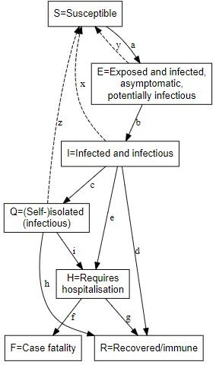

# Simulation parameters

#### Diagr f

|  |  |  |
| --- | --- | --- |
| amRe eter |  | |
| type | SEIQHRF | Type of model: SI, SIR, SIS, SEIR, SEIQHR and SEIQHRF available, but only SEIQHRF is likely to |
|  |  | work in the current version of the code. |
| nsteps | 366 | Number of days for simulation. Note that day 1 is for initialisation, day 2 is the first day of the |
|  |  | simulation, hence default of 366 for 1 year. |
| nsims | 10 | Number of simulations to run and then average. |
| ncores | 10 | Number of CPU cores to use for parallel execution. |
|  |  | Method for progression from E compartment to I. If TRUE, random binomial draws at prog.rate, if |

Param

Default Explanation

##### b prog.ran FALSE d

FALSE, random draws from a Weibull distribution (yes, I know it should be a discrete Weibull distribution but it makes little difference and speed of computation matters), with parameters prog.dist.scale and prog.dist.shape

d,g,h rec.rand FALSE

Method for recovery transition from I, Q or H to R. If TRUE, random binomial draws at prog.rate, if FALSE, random draws from a random draws from a Weibull distribution, with parameters rec.dist.scale and rec.dist.shape

f fat.rand FALSE

Method for case fatality transition from H to F. If TRUE, random binomial draws at fat.rate.base, if FALSE, random sample with a sample fraction also given by fat.rate.base. However, if the current number of patients in the H (needs hospitalisation) compartment is above a hospital capacity level specified by hosp.cap, then the fatality rate is the mean of the base fatality rate weighted by the hospital capacity, plus a higher rate, specified by fat.rate.overcap, weighted by the balance of those requiring hospitalisation (but who can't be accommodated). By setting fat.rate.overcap higher, the effect of exceeding the capacity of the health care system can be simulated. There is also a coefficient fat.tcoeff for the fatality rates that increases them as a linear function of the number of days the individual has been in the H compartment. Use of the co-efficient better approximates the trapezoid survival time distribution typical of ICU patients.

c

quar.ran FALSE d

Method for self-isolation transition from I to Q. If TRUE, random binomial draws at quar.rate, if FALSE, random sample with a sample fraction

also given by `quar.rate.

e,i

hosp.ra FALSE nd

Method for transition from I or Q to H -- that is, from infectious or from self-isolated to requiring hospitalisation. If TRUE, random binomial draws at hosp.rate, if FALSE, random sample with a sample fraction also given by `hosp.rate.

e,i

disch.ra

nd FALSE

Method for transition from H to R -- that is, from requiring hospitalisation to recovered. If TRUE, random binomial draws at disch.rate, if FALSE, random sample with a sample fraction also given by disch.rate. Note that the only way out of the H

compartment is recovery or death.

infectio n.FUN

infection.sei qhrf.icm

No, being infected with SARS-CoV2 is not fun. Rather this is the the name of the function to implement infection processes. Use the default.

departur departures. Handles background demographics, specifically es.FUN seiqhrf.icm departures (deaths not due to the virus, and

emigration). Use the default.

arrivals. FUN

arrivals.icm

Handles background demographics, specifically arrivals (births and immigration). Uses the original EpiModel code currently. A replacement that implements modelling the arrival of infected individuals is under development -- but for now, all arrivals go into the S compartment.

Utility function that collects prevalence and get_prev get_prev.sei transition time data from each run and stores it

.FUN qhrf.icm away in the simulation result object. Use the

default.

s.num 9997

Initial number of \**S* compartment individuals in the simulated population. An overall population of 10,000 is a good compromise. A set of models will still take several minutes or more to run, in parallel.

e.num

0

Initial number of E compartment individuals in the

simulated population.

i.num 3 Initial number of I compartment individuals in the simulated population.

q.num

0

Initial number of Q compartment individuals in the

simulated population.

h.num 0 Initial number of H compartment individuals in the

simulated population.

r.num

0

Initial number of R compartment individuals in the

simulated population.

f.num 0 Initial number of F compartment individuals in the

simulated population.

x

act.rate.

i 10

The number of exposure events (*acts*) between

infectious individuals in the I compartment and susceptible individuals in the S compartment, per day. It's stochastic, so the rate is an average, some individuals may have more or less. Note that not every exposure event results in infection - that is governed by the inf.prob.i parameters (see below). Reducing act.rate.i is equivalent to increasing

social distancing by people in the I compartment.

1. inf.prob. 0.05 i

Probability of passing on infection at each exposure event for interactions between infectious people in the I compartment and susceptibles in S. Reducing inf.prob.i is equivalent to increasing hygiene measures, such as not putting hands in eyes, nose or moth, use of hand sanitisers, wearing masks by the infected, and so on.

y

act.rate.

e 10

The number of exposure events (*acts*) between

infectious individuals in the E compartment and susceptible individuals in the S compartment, per day. Otherwise as for act.rate.i.

1. inf.prob. 0.02 e

Probability of passing on infection at each exposure event for interactions between infectious people in the E compartment and susceptibles in

S. Note the default is lower than for inf.prob.i reflecting the reduced infectivity of infected but asymptomatic people (the E compartment). Otherwise as for inf.exp.i.

z

act.rate.

q 2.5

The number of exposure events (*acts*) between

infectious individuals in the Q compartment (isolated, self or otherwise) and susceptible individuals in the S compartment, per day. Note the much lower rate than for the I and E compartments, reflecting the much greater degree of social isolation for someone in (self-)isolation. The exposure event rate is not zero for this group,

just much less. Otherwise as for act.rate.i.

1. inf.prob. q

0.02

Probability of passing on infection at each exposure event for interactions between infectious people in the Q compartment and susceptibles in

S. Note the default is lower than for inf.prob.i reflecting the greater care that self-isolated individuals will, on average, take regarding hygiene measures, such as wearing masks, to limit spread to others. Otherwise as for inf.exp.i.

c

quar.rat 1/30 e

Rate per day at which symptomatic (or tested positive), infected I compartment people enter self-isolation (Q compartment). Asymptomatic E compartment people can't enter self-isolation because they don't yet know they are infected.

Default is a low rate reflecting low community awareness or compliance with self-isolation requirements or practices, but this can be tweaked

when exploring scenarios.

e,i

hosp.rat 1/100 e

Rate per day at which symptomatic (or tested positive), infected I compartment people or self-isolated Q compartment people enter the

state of requiring hospital care -- that is, become serious cases. A default rate of 1% per day with an average illness duration of about 10 days means a bit less than 10% of cases will require hospitalisation, which seems about right (but can be tweaked, of course).

g

disch.ra 1/15 te

Rate per day at which people needing

hospitalisation recover.

b prog.rat 1/10 e

Rate per day at which people who are infected but asymptomatic (E compartment) progress to becoming symptomatic (or test-positive), the I compartment. See prog.rand above for more details.

b

prog.dis

t.scale 5

Scale parameter for Weibull distribution for

progression, see prog.rand for details.

b prog.dis t.shape

1.5 Shape parameter for Weibull distribution for progression, see prog.rand for details. Read up on

the Weibull distribution before changing the default.

d rec.rate 1/20

Rate per day at which people who are infected and symptomatic (I compartment) recover, thus entering the R compartment. See rec.rand above for more details.

d rec.dist. scale

35 Scale parameter for Weibull distribution for recovery, see rec.rand for details.

d

rec.dist.

shape 1.5

Shape parameter for Weibull distribution for

recovery, see rec.rand for details. Read up on the Weibull distribution before changing the default.

f fat.rate. 1/50 base

Baseline mortality rate per day for people needing hospitalisation (deaths due to the virus). See fat.rand for more details.

f

hosp.ca

p 40

Number of available hospital beds for the

modelled population. See fat.rand for more details.

f fat.rate. 1/25 overcap

Mortality rate per day for people needing hospitalisation but who can't get into hospital due to the hospitals being full (see hosp.cap and fat.rand). The default rate is twice that for those who do get into hospital.

f

fat.tcoef

f 0.5

Time co-efficient for increasing mortality rate as time in the H compartment increases for each

individual in it. See fat.rand for details.

vital TRUE Enables demographics, that is, arrivals and

departures, to and from the simulated population.

a.rate

Background demographic arrival rate. Currently all

(10.5/365)/ arrivals go into the S compartment, the default is 1000 approximately the daily birth rate for Australia. Will

be extended to cover immigration in future

versions.

dq.rate, dh.rate, dr.rate

crude death rates. Can be used to model emigration as well as deaths.

out mean

Summary function for the simulation runs. median is also available, or percentiles, see the EpiModel documentation.

**Time-variant parameters**

nsteps=366

quar.rate = c(rep(1/10,30), rep(1/3, 335))

**simulate() wrapper function**

# function to set-up and run the baseline simulations simulate <- function(# control.icm params

type = "SEIQHRF",

nsteps = 366,

nsims = 8,

ncores = 4, prog.rand = FALSE, rec.rand = FALSE, fat.rand = TRUE, quar.rand = FALSE, hosp.rand = FALSE, disch.rand = TRUE,

infection.FUN = infection.seiqhrf.icm, recovery.FUN = progress.seiqhrf.icm, departures.FUN = departures.seiqhrf.icm, arrivals.FUN = arrivals.icm, get_prev.FUN = get_prev.seiqhrf.icm,

# init.icm params s.num = 9997, e.num=0,

i.num = 3, q.num=0,

h.num=0, r.num = 0,

f.num = 0,

# param.icm params

|  |  |  |
| --- | --- | --- |
| inf.prob.e | = | 0.02, |
| act.rate.e | = | 10, |
| inf.prob.i | = | 0.05, |
| act.rate.i | = | 10, |
| inf.prob.q | = | 0.02, |
| act.rate.q | = | 2.5, |

quar.rate = 1/30, hosp.rate = 1/100, disch.rate = 1/15, prog.rate = 1/10, prog.dist.scale = 5,

prog.dist.shape = 1.5, rec.rate = 1/20, rec.dist.scale = 35,

rec.dist.shape = 1.5, fat.rate.base = 1/50, hosp.cap = 40, fat.rate.overcap = 1/25, fat.tcoeff = 0.5,

vital = TRUE,

a.rate = (10.5/365)/1000, a.prop.e = 0.01,

a.prop.i = 0.001,

a.prop.q = 0.01, ds.rate = (7/365)/1000, de.rate = (7/365)/1000, di.rate = (7/365)/1000, dq.rate = (7/365)/1000,

dh.rate = (20/365)/1000, dr.rate = (7/365)/1000, out="mean"

) {

control <- control.icm(type = type,

nsteps = nsteps, nsims = nsims, ncores = ncores,

prog.rand = prog.rand, rec.rand = rec.rand, infection.FUN = infection.FUN, recovery.FUN = recovery.FUN, arrivals.FUN = arrivals.FUN,

departures.FUN = departures.FUN, get_prev.FUN = get_prev.FUN)

init <- init.icm(s.num = s.num,

e.num = e.num,

i.num = i.num, q.num = q.num, h.num = h.num, r.num = r.num, f.num = f.num)

param <- param.icm(inf.prob.e = inf.prob.e,

act.rate.e = act.rate.e, inf.prob.i = inf.prob.i, act.rate.i = act.rate.i, inf.prob.q = inf.prob.q, act.rate.q = act.rate.q, quar.rate = quar.rate, hosp.rate = hosp.rate, disch.rate = disch.rate, prog.rate = prog.rate,

prog.dist.scale = prog.dist.scale, prog.dist.shape = prog.dist.shape, rec.rate = rec.rate, rec.dist.scale = rec.dist.scale, rec.dist.shape = rec.dist.shape, fat.rate.base = fat.rate.base, hosp.cap = hosp.cap,

fat.rate.overcap = fat.rate.overcap, fat.tcoeff = fat.tcoeff,

vital = vital, a.rate = a.rate, a.prop.e = a.prop.e, a.prop.i = a.prop.i, a.prop.q = a.prop.q, ds.rate = ds.rate, de.rate = de.rate, di.rate = di.rate, dq.rate = dq.rate, dh.rate = dh.rate, dr.rate = dr.rate)

sim <- icm.seiqhrf(param, init, control) sim_df <- as.data.frame(sim, out=out)

return(list(sim=sim, df=sim_df))

}

**Running simulations**

baseline_sim <- simulate(ncores = 4)

# define a function to extract timings and assemble a data # frame

get_times <- function(simulate_results) { sim <- simulate_results$sim

for (s in 1:sim$control$nsims) { if (s == 1) {

times <- sim$times[[paste("sim", s, sep = "")]] times <- times %>% mutate(s = s)

} else {

times <- times %>% bind_rows(sim$times[[paste("sim", s, sep = "")]] %>% mutate(s = s))

}

}

times <- times %>% mutate(infTime = ifelse(infTime < 0, -5, infTime), expTime = ifelse(expTime < 0, -5, expTime)) %>% mutate(incubation_period = infTime - expTime, illness_duration

= recovTime -

expTime, illness_duration_hosp = dischTime - expTime, hosp_los = dischTime - hospTime, quarantine_delay =

quarTime -

infTime, survival_time = fatTime - infTime) %>%

select(s, incubation_period, quarantine_delay, illness_duration,

illness_duration_hosp, hosp_los, survival_time) %>%

pivot_longer(-s, names_to = "period_type", values_to = "duration") %>%

mutate(period_type = factor(period_type, levels = c("incubation_period",

"quarantine_delay", "illness_duration", "illness_duration_hosp",

"hosp_los", "survival_time"), labels = c("Incubation

period",

"Delay entering isolation", "Illness duration", "Illness

duration (hosp)",

"Hospital care required duration", "Survival time of case fatalities"),

ordered = TRUE)) return(times)

}

times <- get_times(baseline_sim)

times %>% filter(duration <= 30) %>% ggplot(aes(x = duration)) + geom_bar() + facet_grid(period_type ~ ., scales = "free_y") + labs(title = "Duration frequency distributions", subtitle =

"Baseline simulation")

# Visualise prevalence

baseline_plot_df <- baseline_sim$df %>% # use only the prevalence columns

select(time, s.num, e.num, i.num, q.num, h.num, r.num, f.num) %>% # examine only the first 100 days since it is all over by

# then using the default parameters

filter(time <= 100) %>% pivot_longer(-c(time), names_to = "compartment",

values_to = "count")

# define a standard set of colours to represent compartments compcols <- c(s.num = "yellow", e.num = "orange", i.num = "red",

q.num = "cyan", h.num = "magenta", r.num = "lightgreen", f.num = "black")

complabels <- c(s.num = "Susceptible", e.num = "Infected/asymptomatic", i.num = "Infected/infectious", q.num = "Self-isolated", h.num =

"Requires hospitalisation",

r.num = "Recovered", f.num = "Case fatality")

baseline_plot_df %>% ggplot(aes(x = time, y = count, colour = compartment)) +

geom_line(size = 2, alpha = 0.7) + scale_colour_manual(values =

compcols,

labels = complabels) + theme_dark() + labs(title = "Baseline simulation",

x = "Days since beginning of epidemic", y = "Prevalence (persons)")

baseline_plot_df %>% filter(compartment %in% c("e.num", "i.num", "q.num", "h.num", "f.num")) %>% ggplot(aes(x = time, y = count, colour = compartment)) + geom_line(size = 2, alpha = 0.7) + scale_colour_manual(values = compcols, labels = complabels) + theme_dark() + labs(title = "Baseline simulation", x = "Days since

beginning of epidemic",

y = "Prevalence (persons)")

# Checking the basic reproduction number R0

# get the S-> E compartment flow, which is our daily # incidence rate

incidence_counts <- baseline_sim$df %>% select(time, se.flow) # uncount them

incident_case_dates <- incidence_counts %>% uncount(se.flow) %>% pull(time)

# convert to an incidence object

incidence_all <- incident_case_dates %>% incidence(.)

# plot the incidence curve plot(incidence_all)

# find the peak of the epidemic curve peak_of_epidemic_curve <- find_peak(incidence_all)

# repeat with just the growth part of the epidemic curve incident_case_dates_growth_phase <- incidence_counts %>% filter(time <=

peak_of_epidemic_curve) %>% select(time, se.flow) %>% uncount(se.flow) %>%

pull(time)

incidence_growth_phase <- incident_case_dates_growth_phase %>% incidence(., last_date = peak_of_epidemic_curve)

# specify serial interval mean and SD since the last blog

# post new studies have appeared suggesting 4.5 is a better # mean for the SI

si_mean <- 4.5

si_sd <- 3.4

# get a set of MLE estimates for R0 and plot

res <- get_R(incidence_growth_phase, si_mean = si_mean, si_sd = si_sd) plot(res, "R")

## Running an intervention experiment

quar_rate_ramp <- function(t) {

ifelse(t < 15, 0.0333, ifelse(t <= 30, 0.0333 + (t - 15) *

(0.5 - 0.0333)/15, 0.5))

}

ramp_quar_rate_sim <- simulate(quar.rate = quar_rate_ramp(1:366))

baseline_plot_df %>% mutate(experiment = "Baseline") %>% bind_rows(ramp_quar_rate_sim_plot_df %>%

mutate(experiment = "Ramp up isolation")) %>% filter(compartment

%in%

c("e.num", "i.num", "q.num", "h.num", "f.num")) %>% ggplot(aes(x = time,

y = count, colour = compartment)) + geom_line(size = 2, alpha =

0.7) +

facet_grid(experiment ~ .) + scale_colour_manual(values = compcols, labels = complabels) + theme_dark() + labs(title = "Baseline vs

ramping up isolation simulations",

x = "Days since beginning of epidemic", y = "Prevalence (persons)")

## Running lots of intervention experiments

**Experiment 2 - more hospital beds**

### Over a four week period, let’s ramp up hospital capacity to triple the baseline level, starting at day 15. Hey, China built a 1000+ bed COVID-19 hospital in Wuhan in just 10 days…

hosp_cap_ramp <- function(t) {

ifelse(t < 15, 40, ifelse(t <= 45, 40 + (t - 15) * (120 -

40)/30, 120))

}

raise_hosp_cap_sim <- simulate(hosp.cap = hosp_cap_ramp(1:366))

# Experiment 3 - more social distancing starting at day 15

### Let’s step up social distancing (decrease exposure opportunities), starting at day 15, in everyone except the self-isolated, who are already practising it. But we’ll leave the self-isolation rate at the baseline desultory rate. The increase in social distancing will, when full ramped up by day 30, halve the number of exposure events between the infected and the susceptible each day.

social_distancing_day15_ramp <- function(t) {

ifelse(t < 15, 10, ifelse(t <= 30, 10 - (t - 15) * (10 -

5)/15, 5))

}

t15_social_distancing_sim <- simulate(act.rate.i = social_distancing_day15_ramp(1:366),

act.rate.e = social_distancing_day15_ramp(1:366))

# Experiment 4 - more social

**distancing but starting at day 30**

### Let’s repeat that, but we’ll delay starting the social distancing ramp-up until day 30.

social_distancing_day30_ramp <- function(t) {

ifelse(t < 30, 10, ifelse(t <= 45, 10 - (t - 30) * (10 -

5)/15, 5))

}

t30_social_distancing_sim <- simulate(act.rate.i = social_distancing_day30_ramp(1:366),

act.rate.e = social_distancing_day30_ramp(1:366))

# Experiment 5 - increase both social distancing and increased

**self-isolation rates starting day 15**

quar_rate_ramp <- function(t) {

ifelse(t < 15, 0.0333, ifelse(t <= 30, 0.0333 + (t - 15) *

(0.5 - 0.0333)/15, 0.5))

}

ramp_quar_rate_sim <- simulate(quar.rate = quar_rate_ramp(1:366))

t15_soc_dist_quar_sim <- simulate(act.rate.i = social_distancing_day15_ramp(1:366),

act.rate.e = social_distancing_day15_ramp(1:366), quar.rate =

quar_rate_ramp(1:366))

# Comparing experiments

### Let’s visualise all those experiments in one plot.

plot_df <- baseline_sim$df %>% select(time, s.num, e.num, i.num, q.num, h.num, r.num, f.num) %>% mutate(experiment = "0. Baseline")

%>%

bind_rows(ramp_quar_rate_sim$df %>% select(time, s.num, e.num, i.num, q.num, h.num, r.num, f.num) %>% mutate(experiment = "1.

incr quar @ t=15")) %>%

bind_rows(raise_hosp_cap_sim$df %>% select(time, s.num, e.num, i.num, q.num, h.num, r.num, f.num) %>% mutate(experiment = "2.

incr hos cap @ t=15")) %>%

bind_rows(t15_social_distancing_sim$df %>% select(time, s.num,

e.num, i.num, q.num, h.num, r.num, f.num) %>% mutate(experiment

= "3. incr soc dist @ t=15")) %>% bind_rows(t30_social_distancing_sim$df %>% select(time, s.num,

e.num, i.num, q.num, h.num, r.num, f.num) %>% mutate(experiment

= "4. incr soc dist @ t=30")) %>% bind_rows(t15_soc_dist_quar_sim$df %>% select(time, s.num,

e.num, i.num, q.num, h.num, r.num, f.num) %>% mutate(experiment

= "5. incr soc dist & quar @ t=15")) %>%

filter(time <= 150) %>% pivot_longer(-c(time, experiment), names_to = "compartment", values_to = "count") %>%

filter(compartment %in%

c("e.num", "i.num", "q.num", "h.num", "f.num"))

plot_df %>% ggplot(aes(x = time, y = count, colour = compartment)) + geom_line(size = 1.5, alpha = 0.7) + facet_grid(experiment ~

.) + scale_colour_manual(values = compcols, labels = complabels) +

theme_dark() + labs(title = "Baseline vs experiments", x = "Days since beginning of epidemic",

y = "Prevalence (persons)")

Let’s see that again showing just the *requiring hospitalisation* and *case fatality*

### prevalence numbers.

plot_df %>% filter(compartment %in% c("h.num", "f.num")) %>% ggplot(aes(x = time, y = count, colour = compartment)) + geom_line(size = 1.5, alpha = 0.7) + facet_grid(experiment ~

.) + scale_colour_manual(values = compcols, labels = complabels) + theme_dark() + labs(title = "Baseline vs experiments", x = "Days

since beginning of epidemic",

y = "Prevalence (persons)")

**Experiment 6: 2 week lockdown**

twoweek_lockdown_day15_vector <- c(rep(10, 15), rep(2.5, 15),

rep(10, 336))

twoweek_lockdown_day30_vector <- c(rep(10, 30), rep(2.5, 15),

rep(10, 321))

twoweek_lockdown_day15_sim <- simulate(act.rate.i = twoweek_lockdown_day15_vector,

act.rate.e = twoweek_lockdown_day15_vector)

twoweek_lockdown_day30_sim <- simulate(act.rate.i = twoweek_lockdown_day30_vector,

act.rate.e = twoweek_lockdown_day30_vector)

## Experiment 7: 4 weeks lockdown

fourweek_lockdown_day15_vector <- c(rep(10, 15), rep(2.5, 30),

rep(7.5, 321))

fourweek_lockdown_day30_vector <- c(rep(10, 30), rep(2.5, 30),

rep(7.5, 306))

fourweek_lockdown_day15_sim <- simulate(act.rate.i = fourweek_lockdown_day15_vector,

act.rate.e = fourweek_lockdown_day15_vector, quar.rate = 1:366),

quarantine_ramp(

01)

inf.prob.q = 0.

fourweek_lockdown_day30_sim <- simulate(act.rate.i = fourweek_lockdown_day30_vector,

act.rate.e = fourweek_lockdown_day30_vector, quar.rate = quarantine_ramp(1:366),

inf.prob.q = 0.01)

**3.2 RESULTS AND INFERENCES**

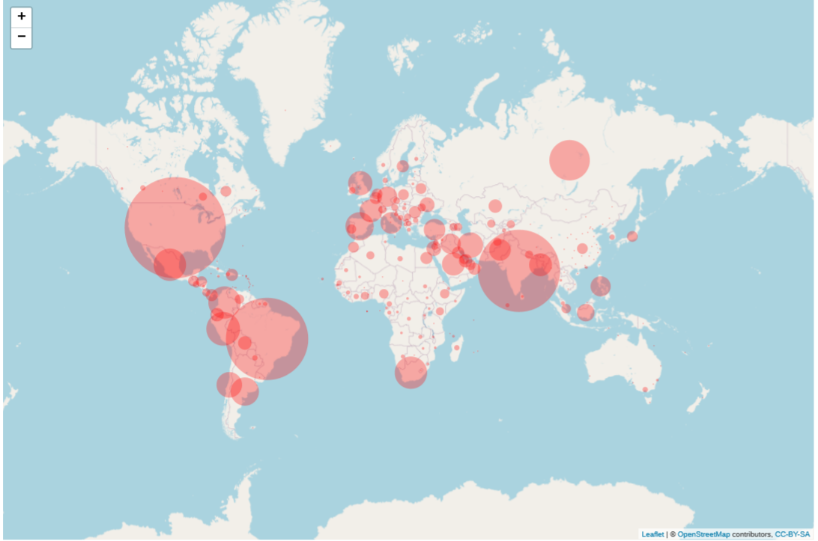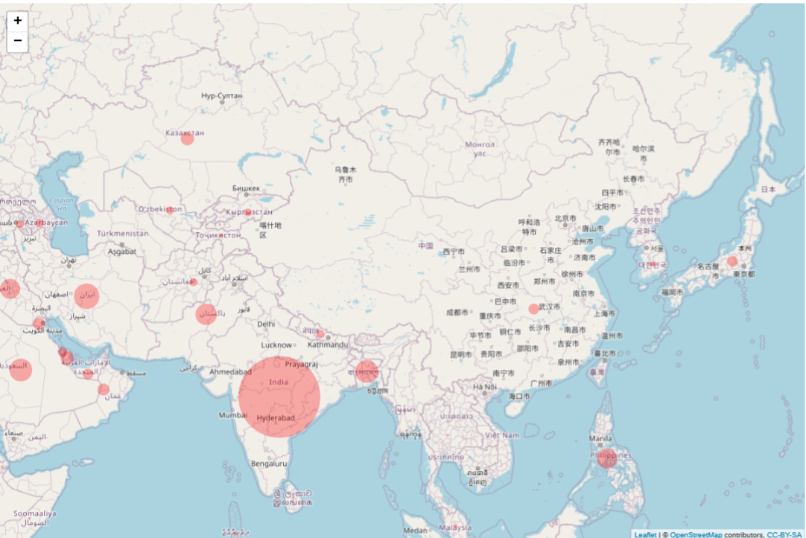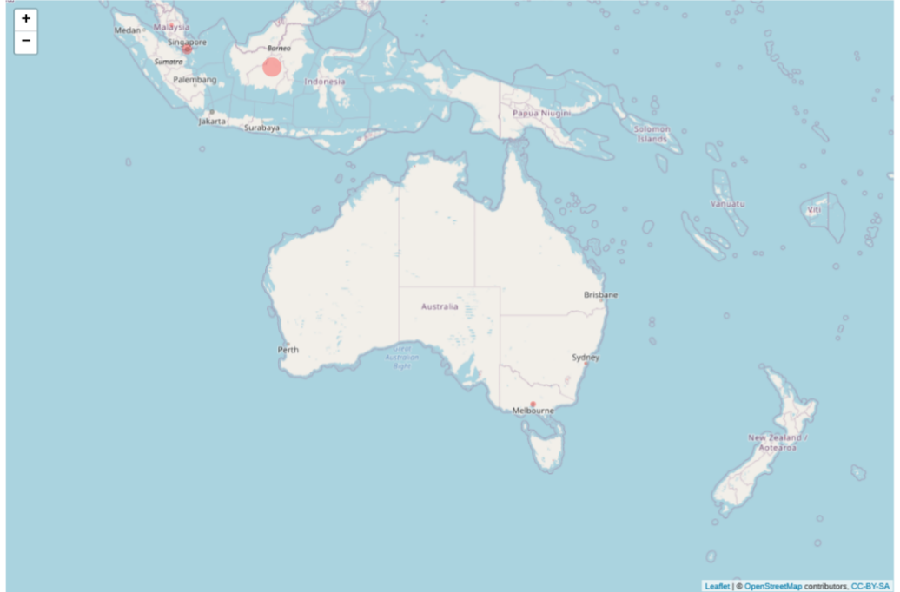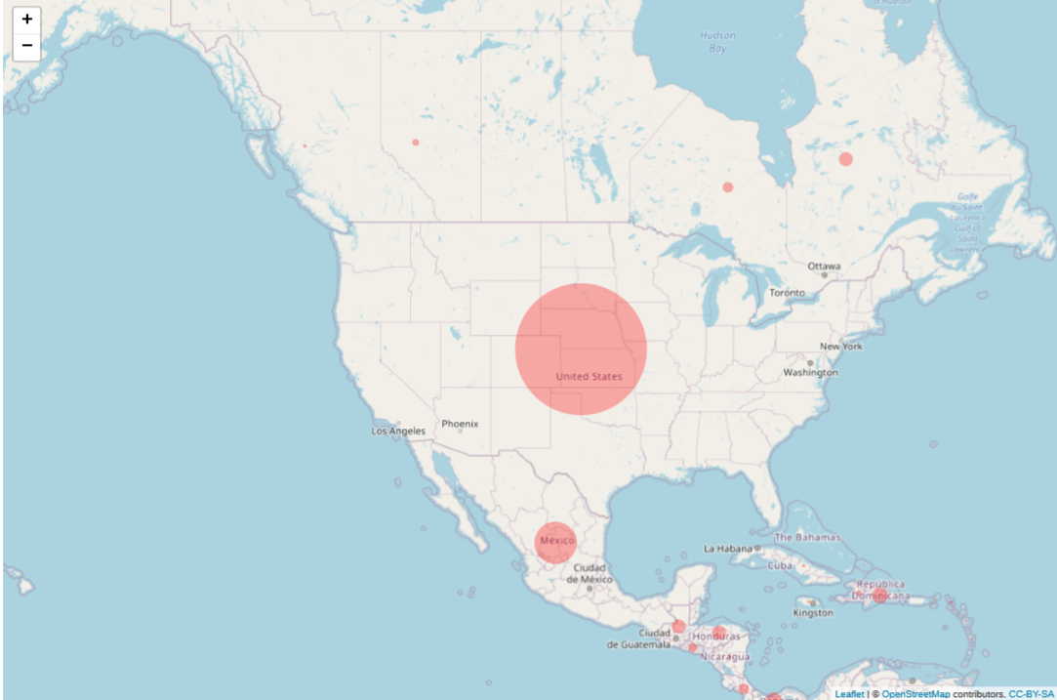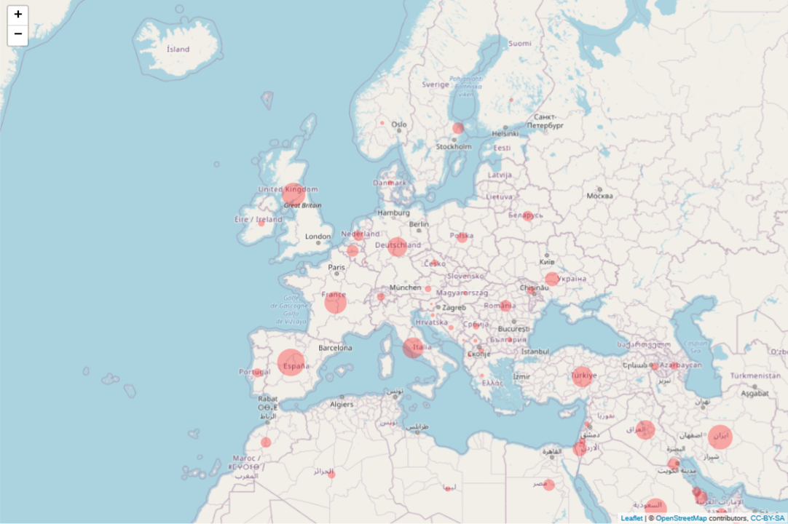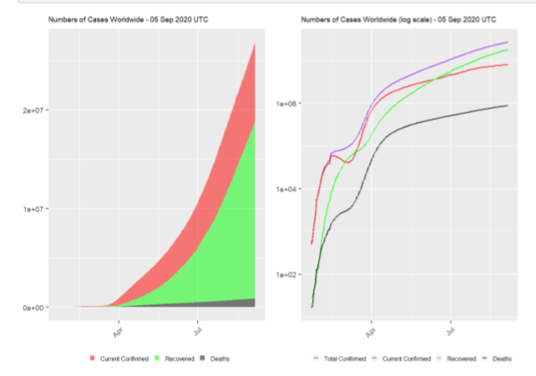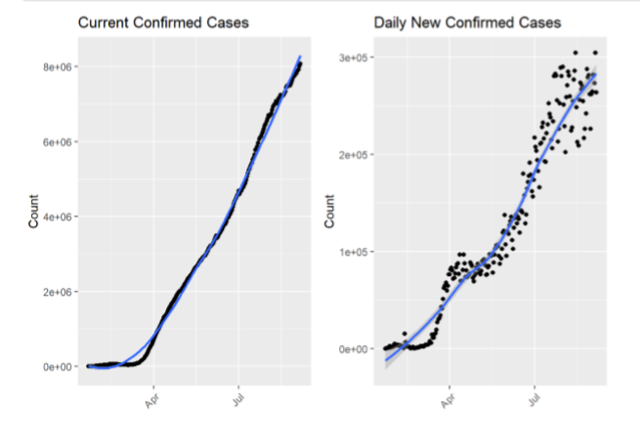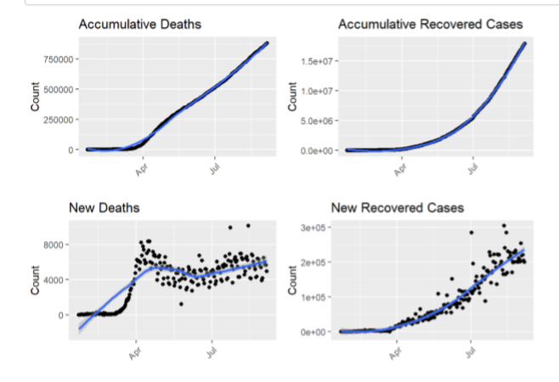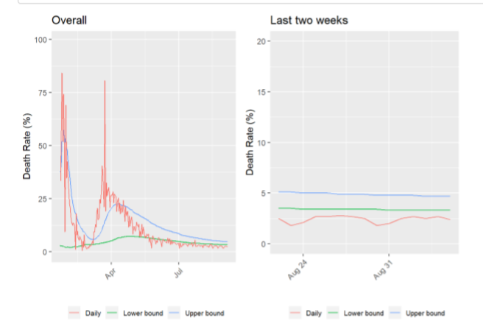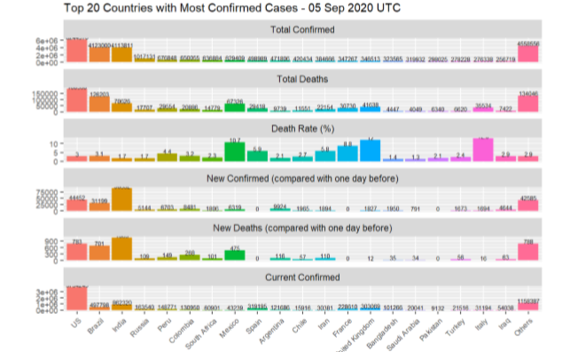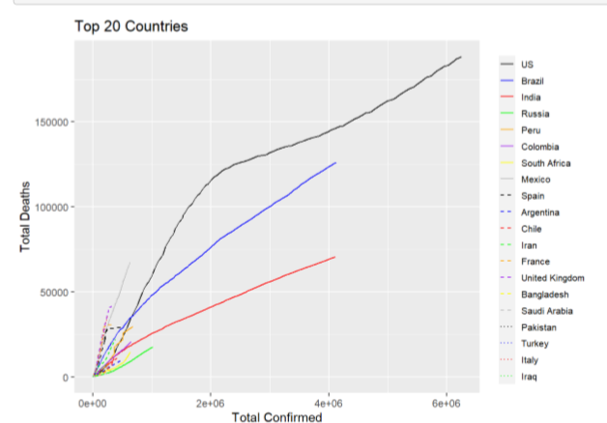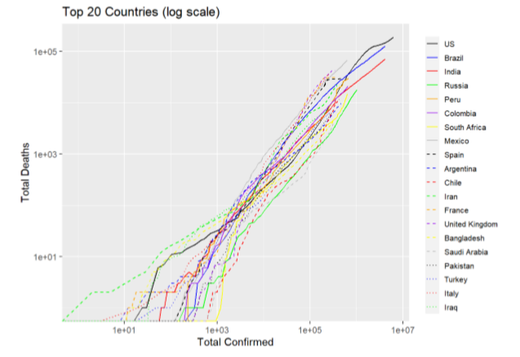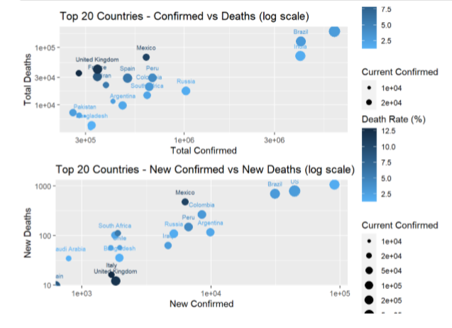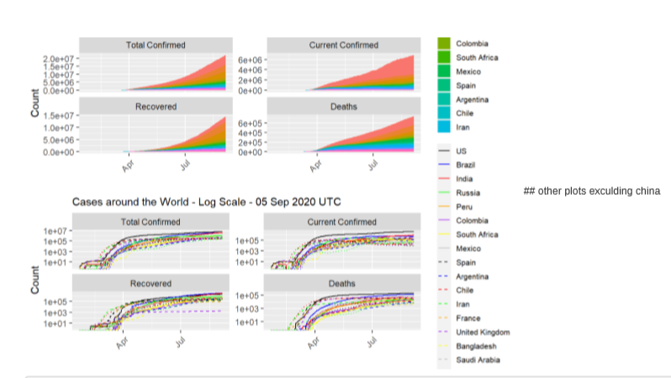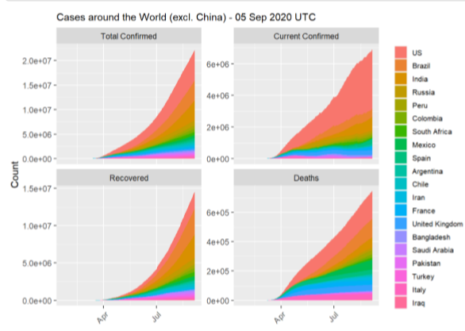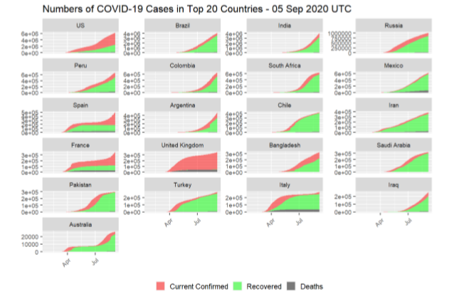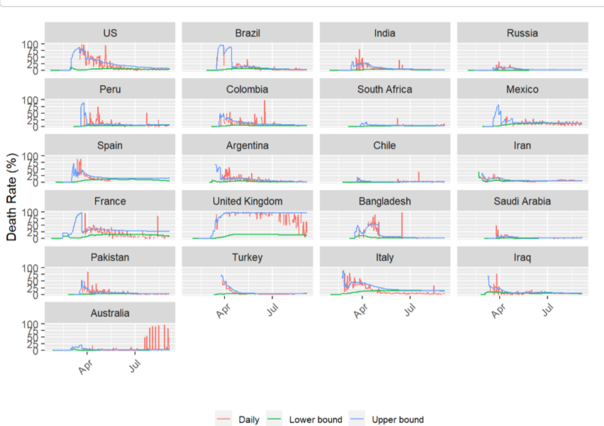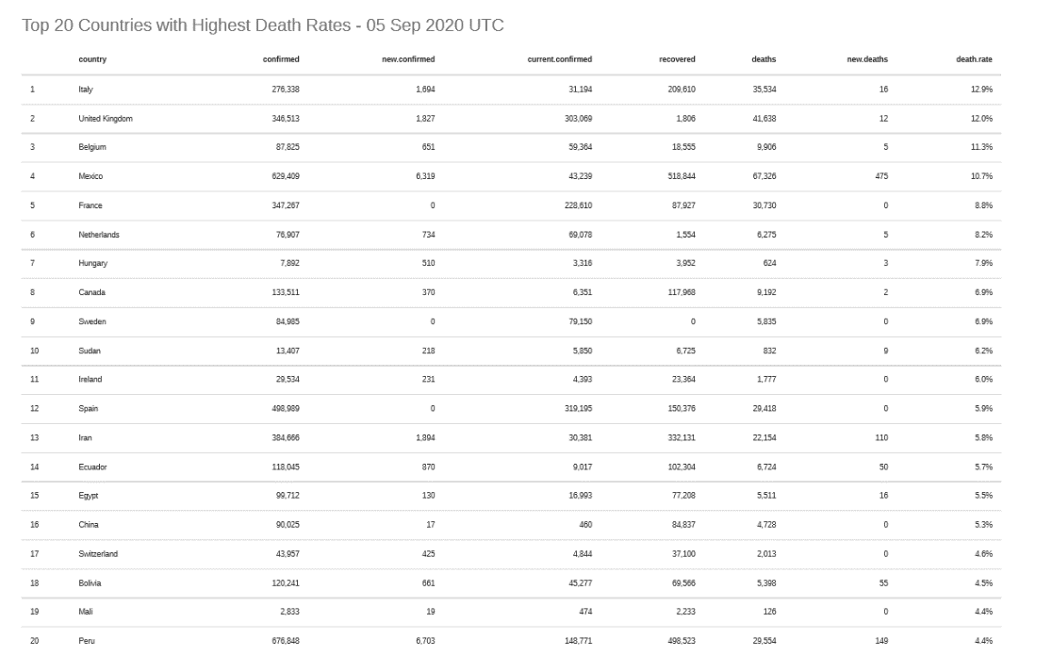

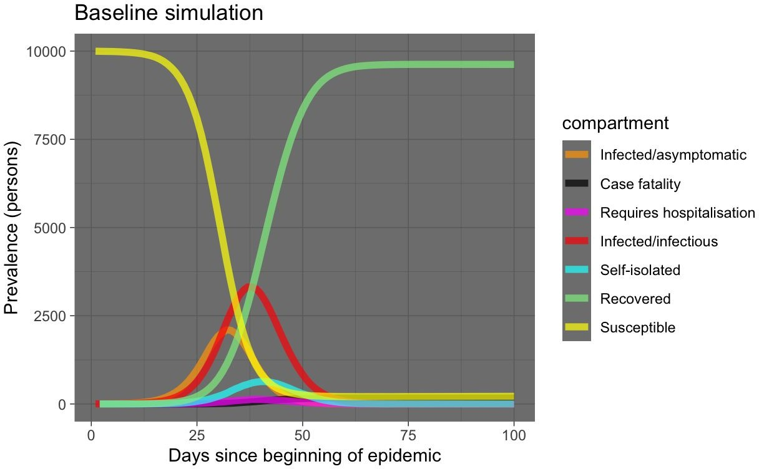

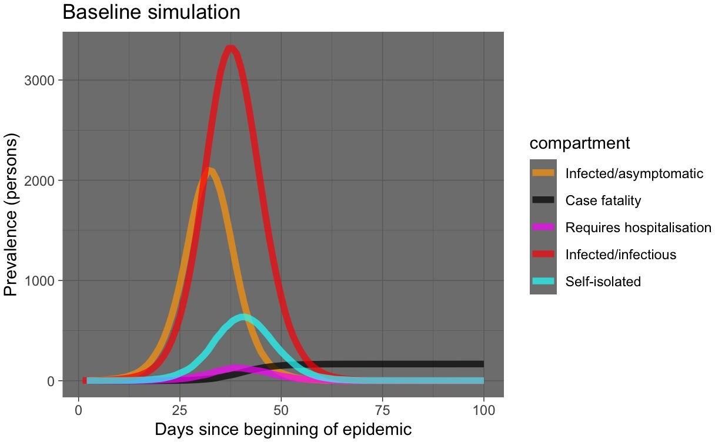

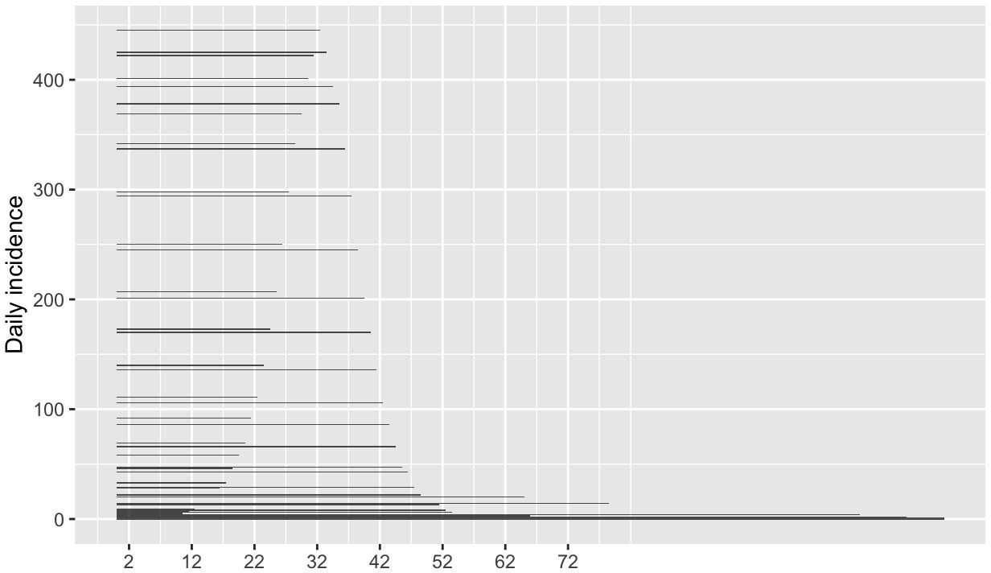

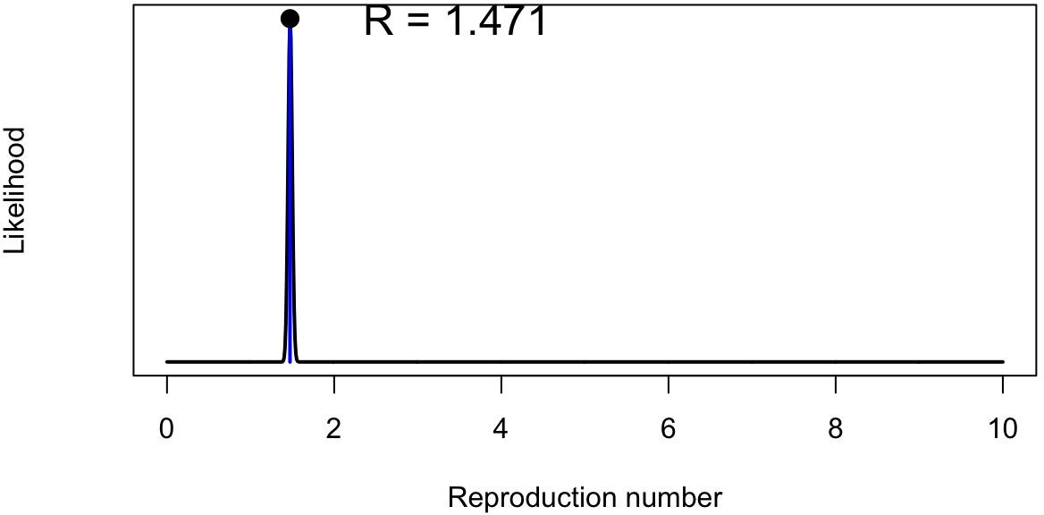

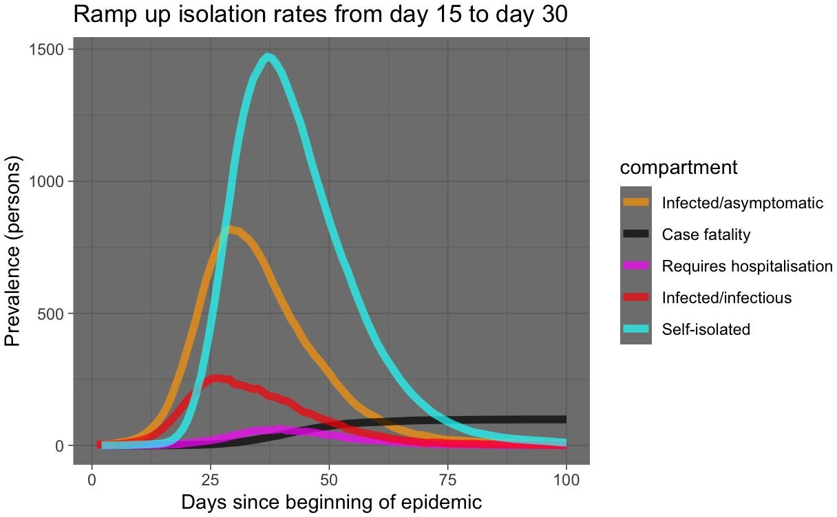

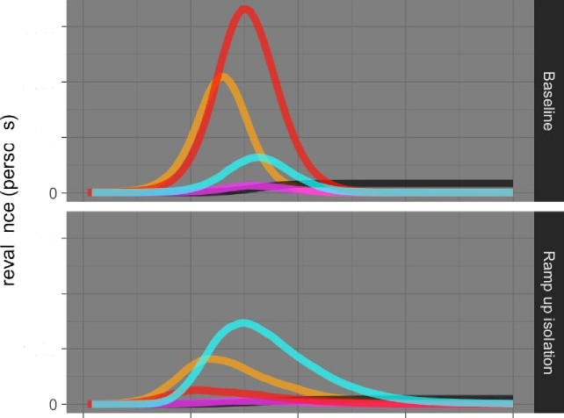

SOOO

2000

T 1000

O 3000

£L 2000

1000

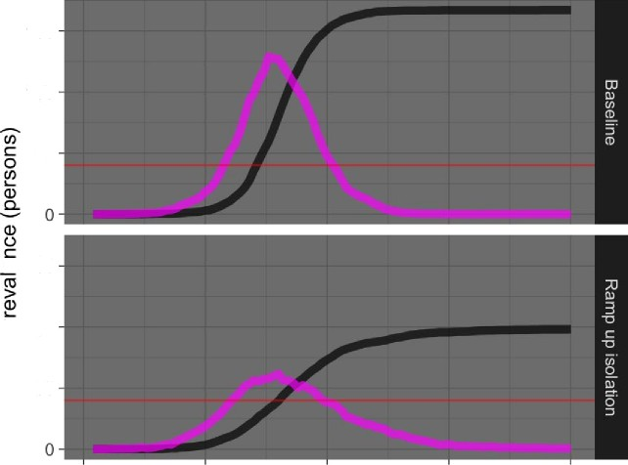

150

100

50

O 150

100

50

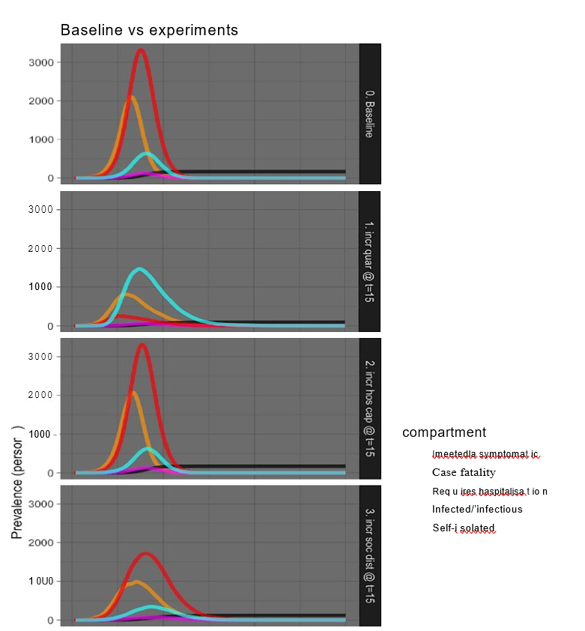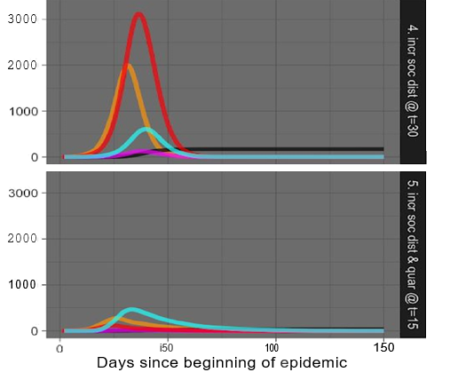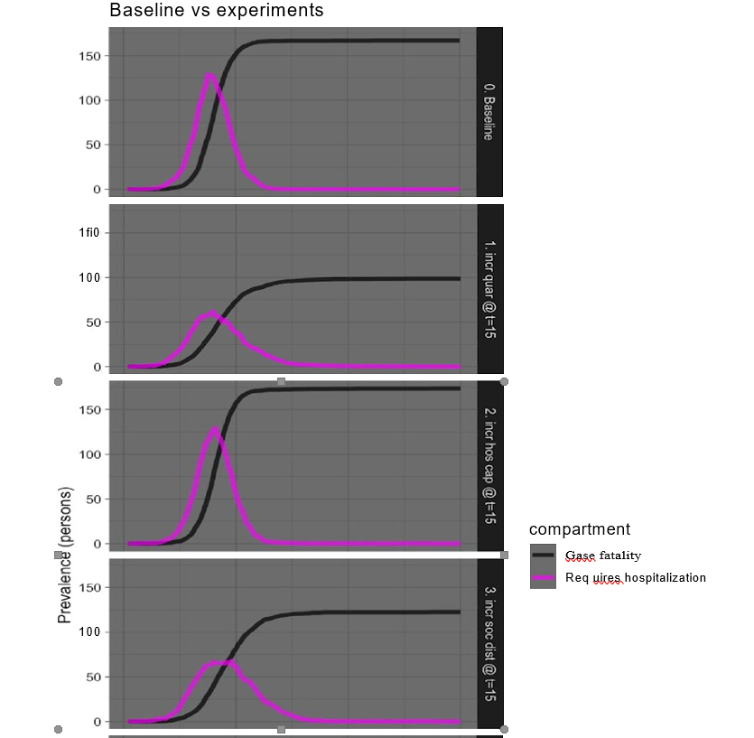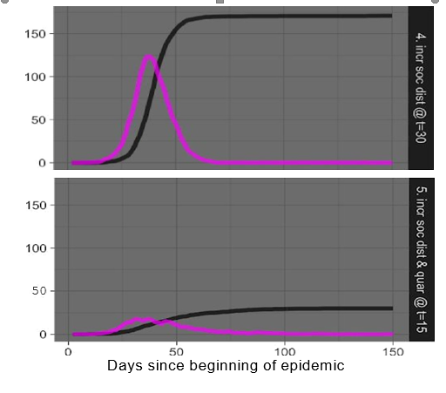

**2 WEEK LOCKDOWN**

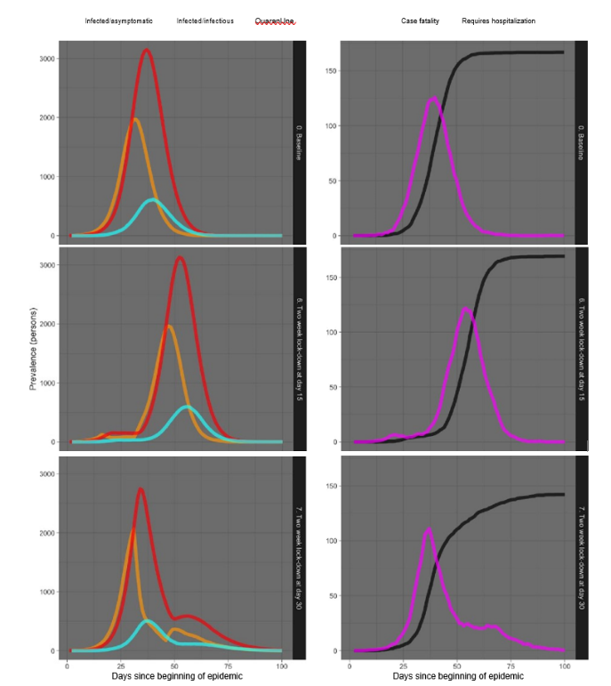

**4 WEEK LOCKDOWN**

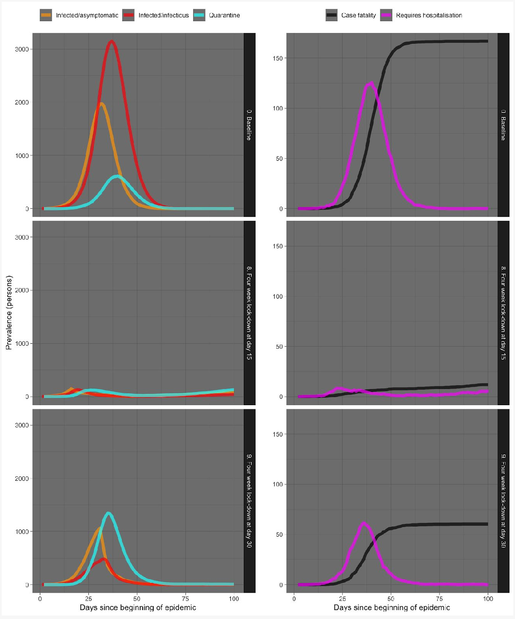

**CHAPTER 4**

**CONCLUSION AND FUTURE WORK**

**4.1 CONCLUSION**

* COVID-19 Analysis was done and implemented.
* It helps to identify what is the situation of each country amongst these crises.
* Its helps to identify the confirmed cases in each country both graphically and theoretically.
* It helps to identify the health facilities available in an area through their recovered cases.
* It helps to identify the death rates and their fatal increase and decrease in an area.
* It helps to identify the change in confirmed cases , death rates after taking certain measures by the authorities like 2 and 4 week lockdown.

**4.2 FUTURE WORK**

* This is an ongoing analysis as still the cases are rising day by day and death rates also.
* Some other type of analysis can also been done after some other measures taken by authorities.
* More and more data will be added to the datasets as we are still fighting with this deadly Coronavirus.

**CHAPTER 5**

**REFERENCES**

* D. Hui et al, "The continuing 2019-nCoV epidemic threat of novel coronavirus to global health - The latest 2019 novel coronavirus outbreak in Wuhan, China," International Journal of Infectious Diseases, vol. 91, pp. 264-266, 2020.
* World Health Organization (WHO), "Coronavirus disease 2019 (COVID-19) Situation Report - 35," WHO, 2020.
* World Health Organization, "2019 Novel Coronavirus (2019-nCoV): Strategic Preparedness and Response Plan," World Health Organization, Geneva, 2020.

**BIODATA**



Name :Tanmay Kumar Sinha

Mobile Number :9871567302

E-mail :tanmaykumar.sinha2018@vitstudent.ac.in

Permanent Address: Rajendar Ng., Flat- C3 , Ghaziabad, Uttar Pradesh,201005



Name : Ankush Badgujar

Mobile Number : 9891665378

E-mail : ankush.badgujar2018@vitstudent.ac.in

Permanent Address: H.No 921/22 Sector 10, Gurgaon, Haryana, 122001



Name : Jigyas Arora

Mobile Number : 7055450664

E-mail : jigyas.arora2018@vitstudent.ac.in

Permanent Address: 109/C Model town, Bareilly

PROJECT VIDEO LINK:

https://www.youtube.com/watch?v=-eyvBoz5xVU